**AWS HANDSONS**

**EC2-Hands-on:**

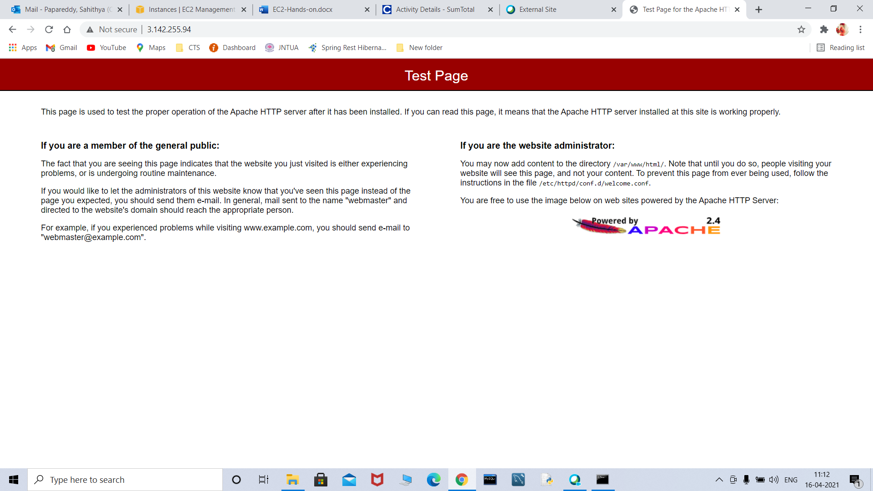

**S3-Hands-on:**

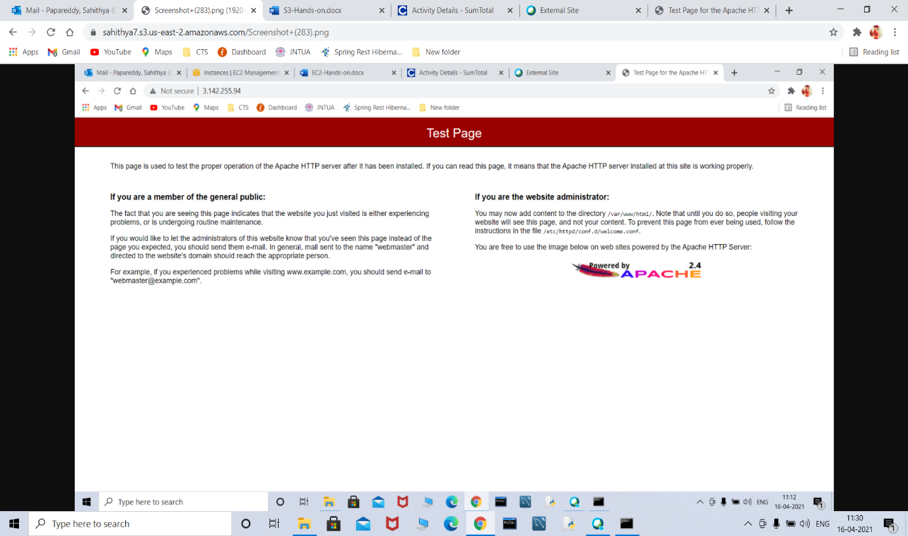

**RDS-Hands-on:**

**Database created**

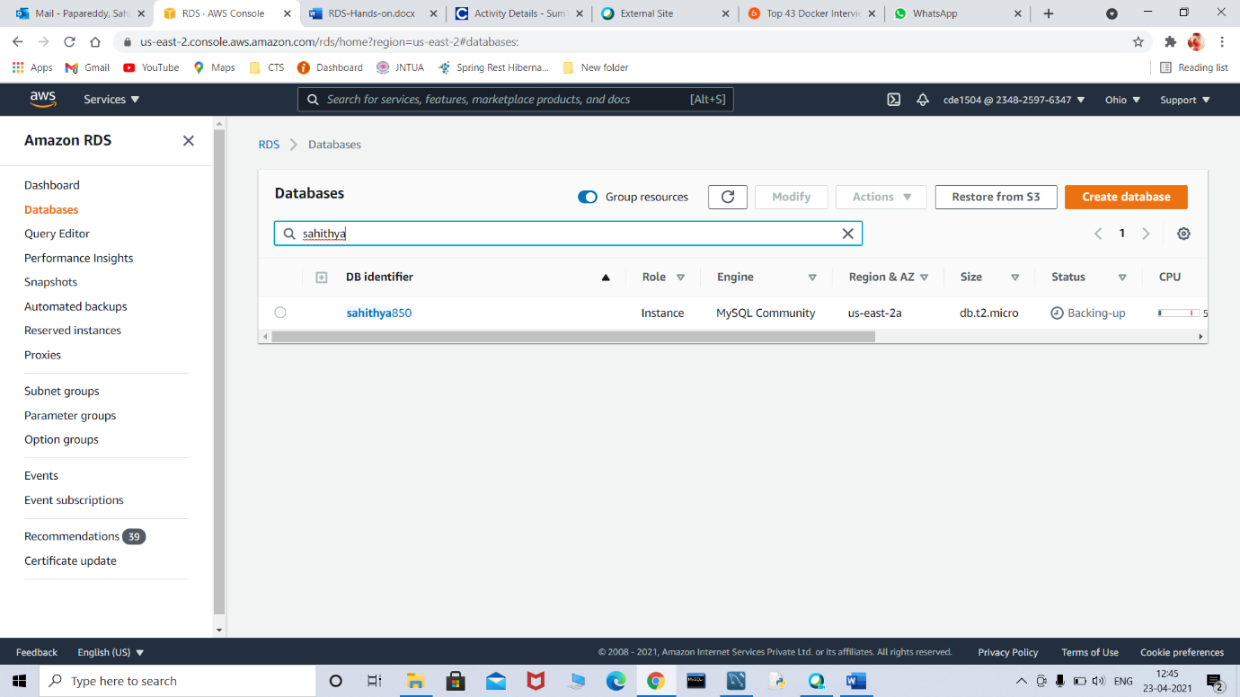

**Connected made successfully**

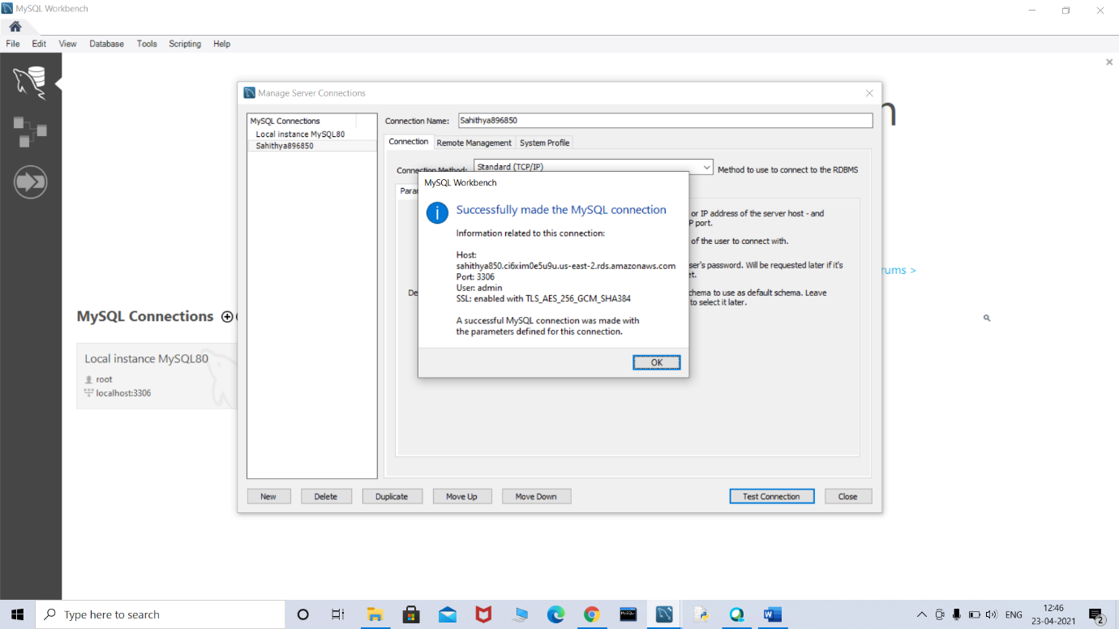

**AWS-lab-hands-on-practice.mp4:**

**CREATE VPC:**

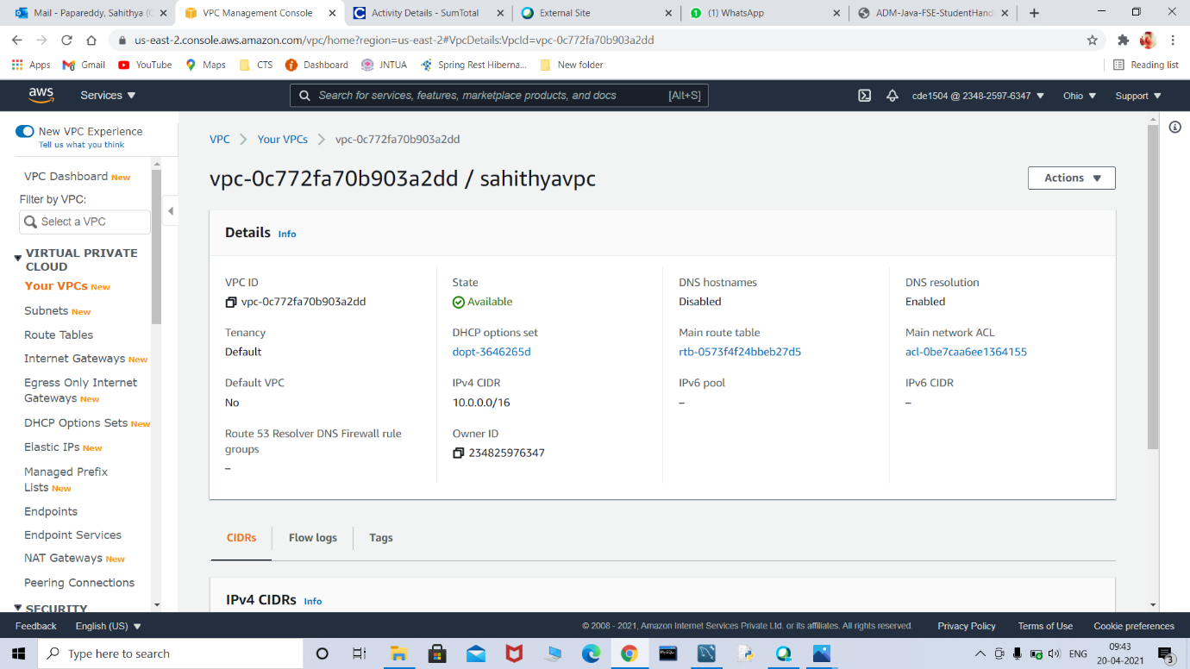

**CREATE SUBNET:**

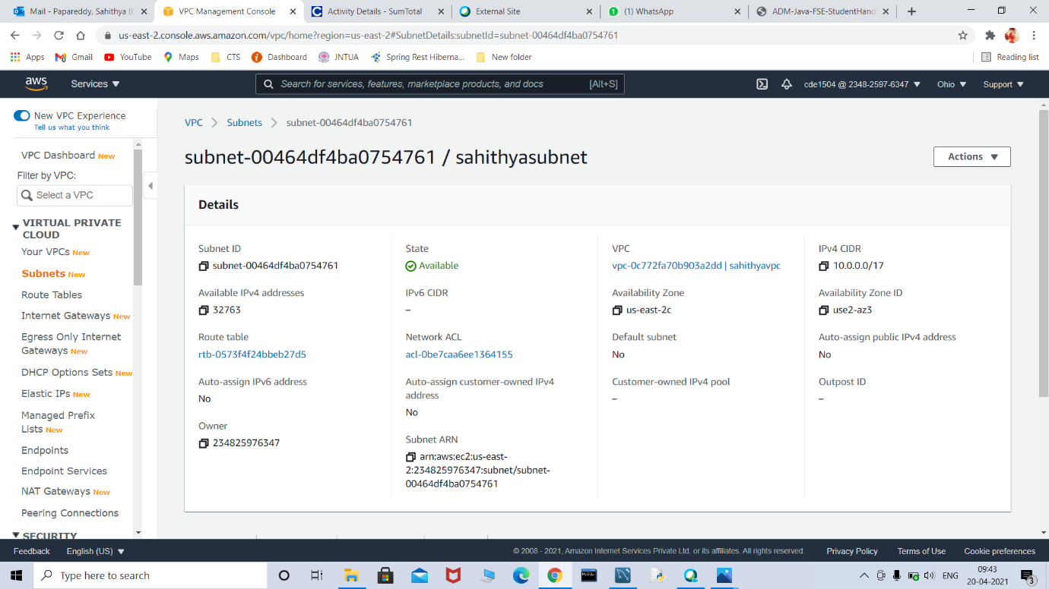

**CREATE INTERNET GATEWAY:**

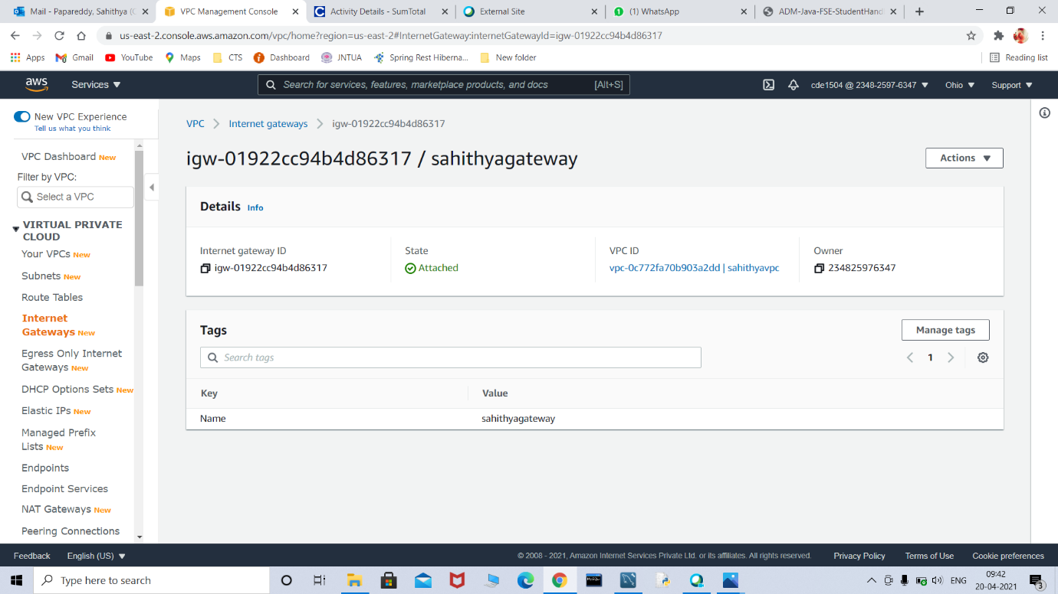

**Browser displayed HELLO WORLD**

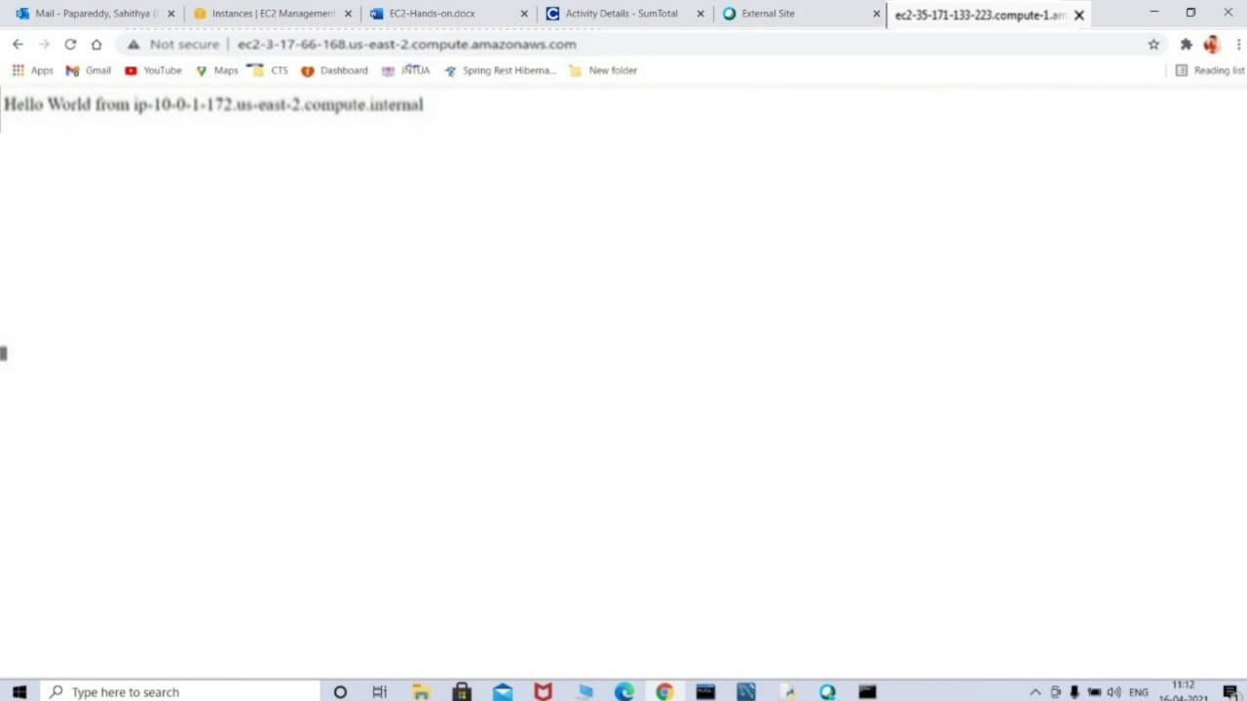

**CICD-lab.mp4:**

**SPRING PROJECT created**

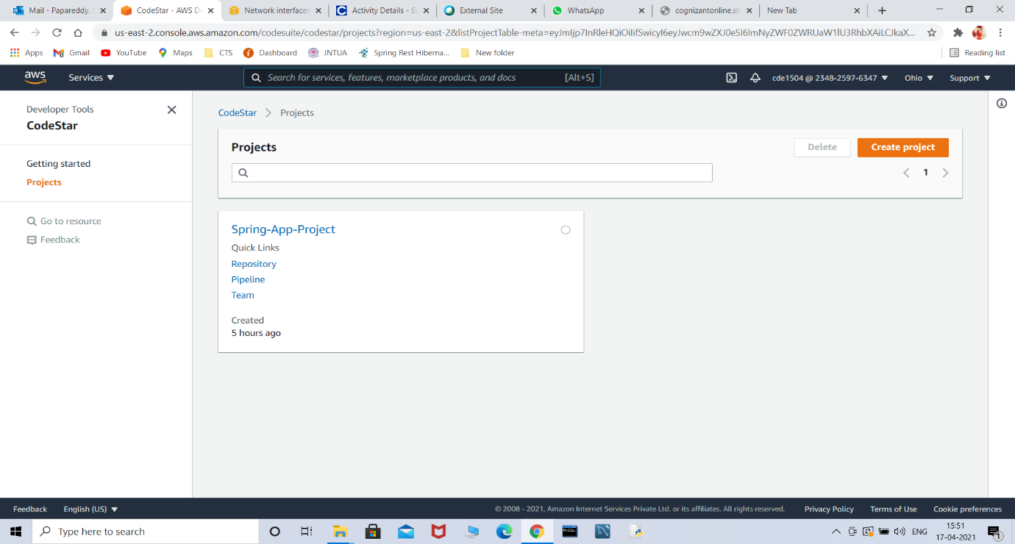

**Successfully a spring web application using CI/CD deployed**

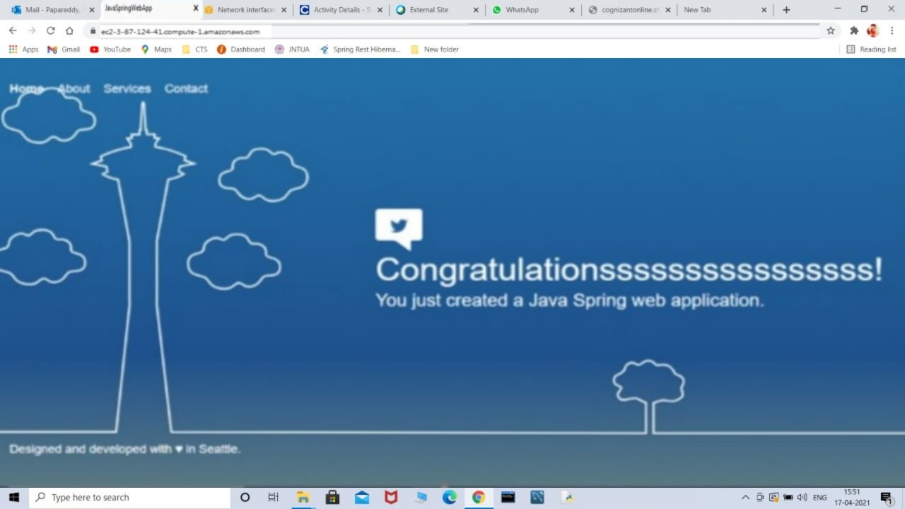

**Spring-REST-with-RDS-Backend:**

**Database created**



**Connected made successfully**

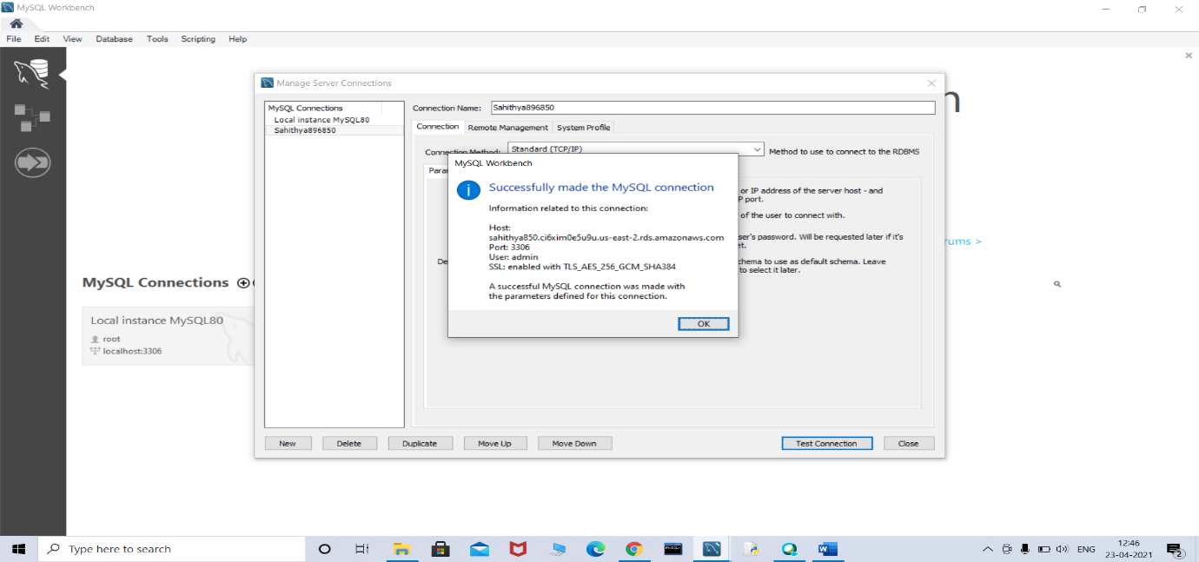

**SQL script**

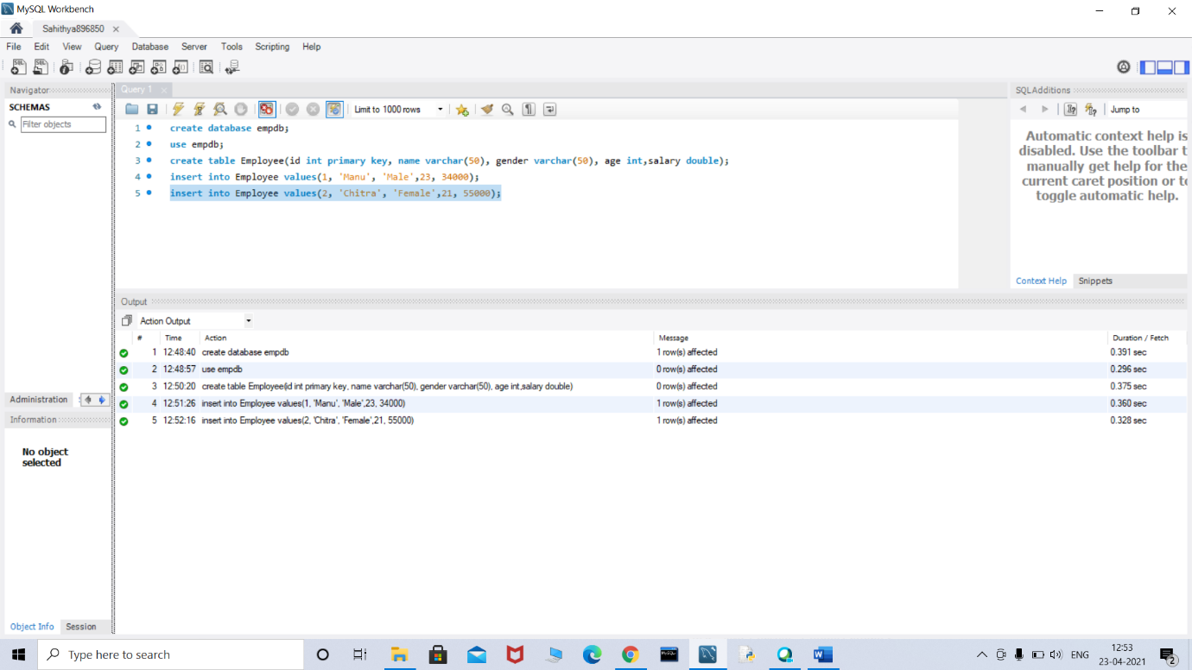

**Spring REST application using Spring Boot**

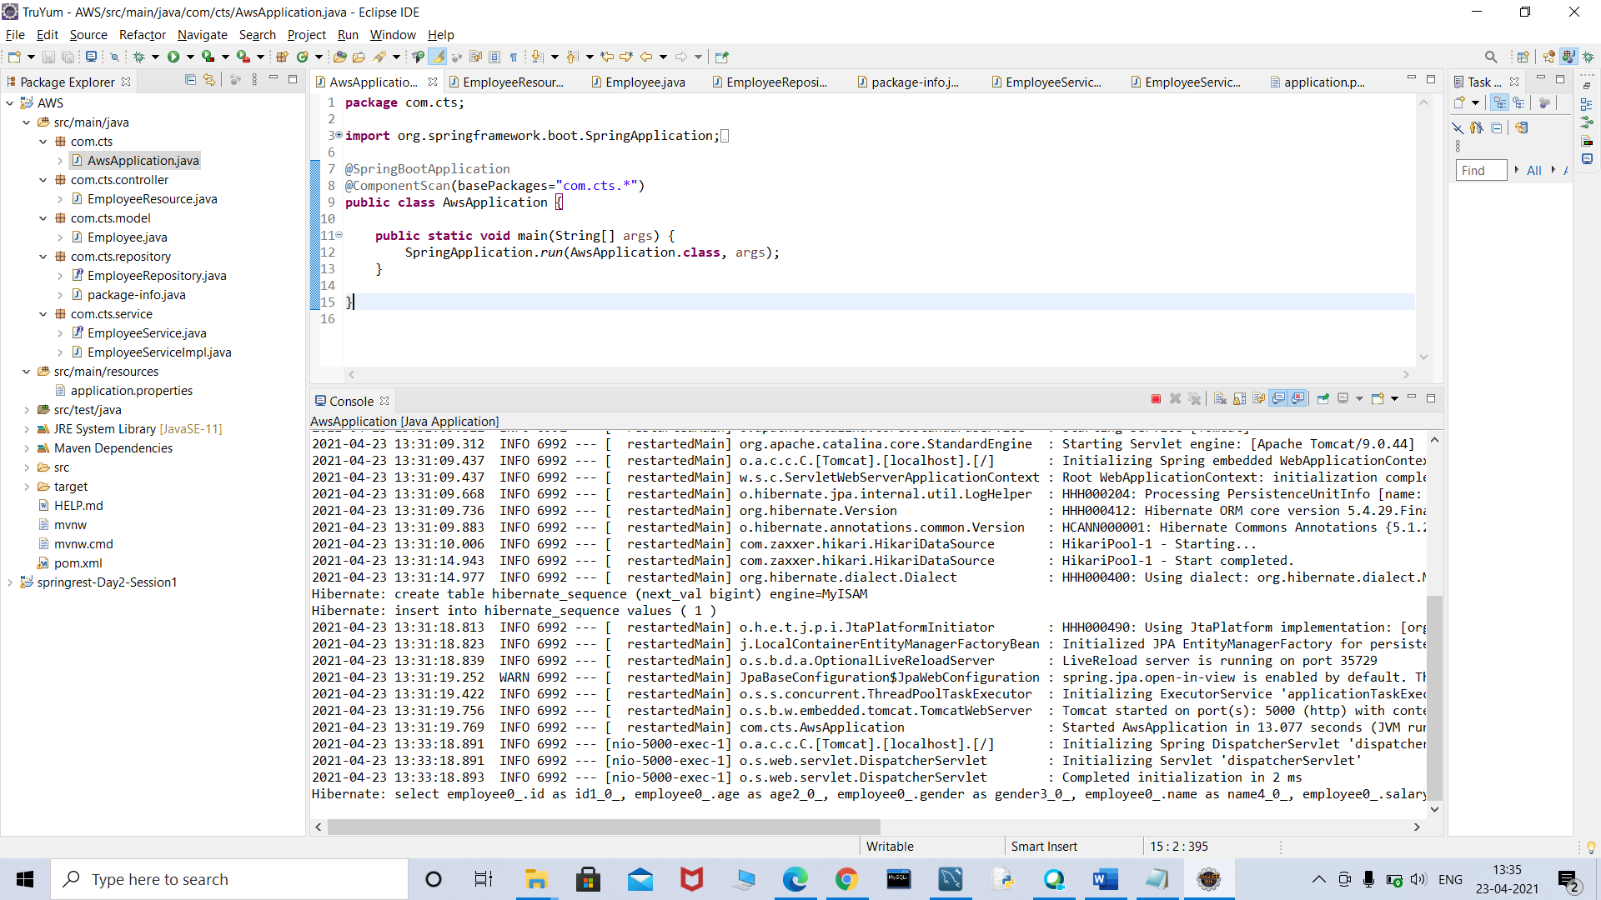

**Start the application locally and type the url in the browser window as shown above**

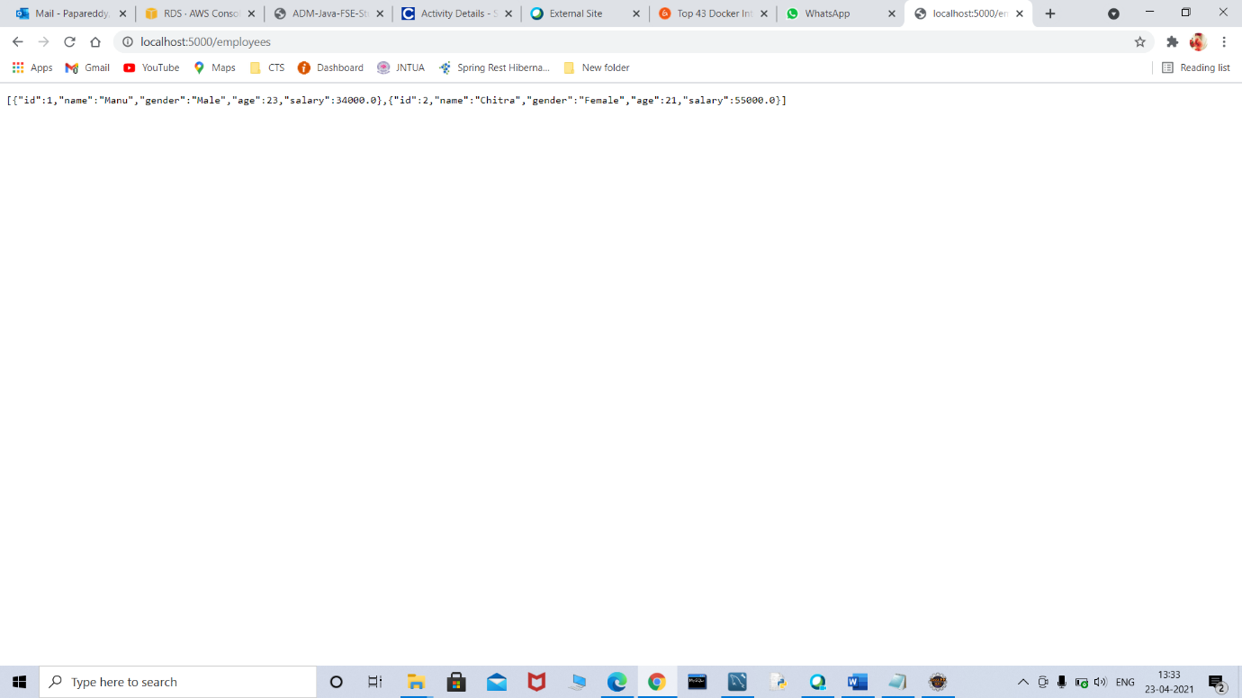

**Elastic Beanstalk environment created**

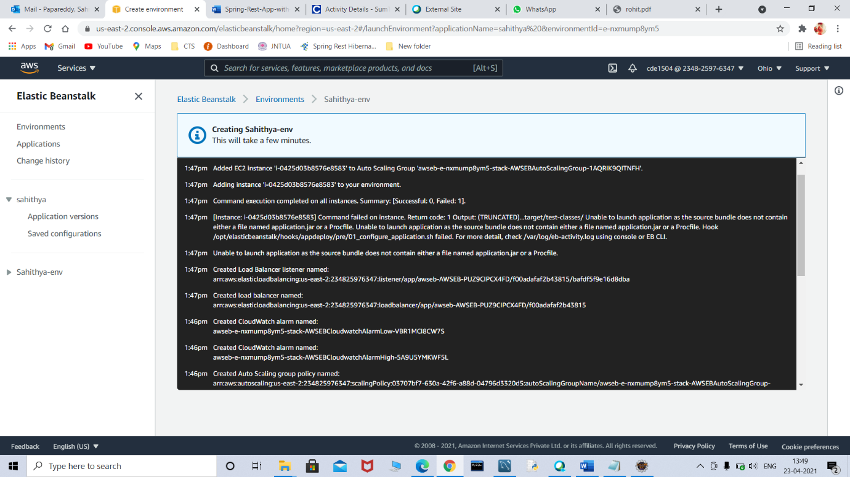

**Swagger-Hands-on:**

**Swagger to create documentation for RESTful/microservices**

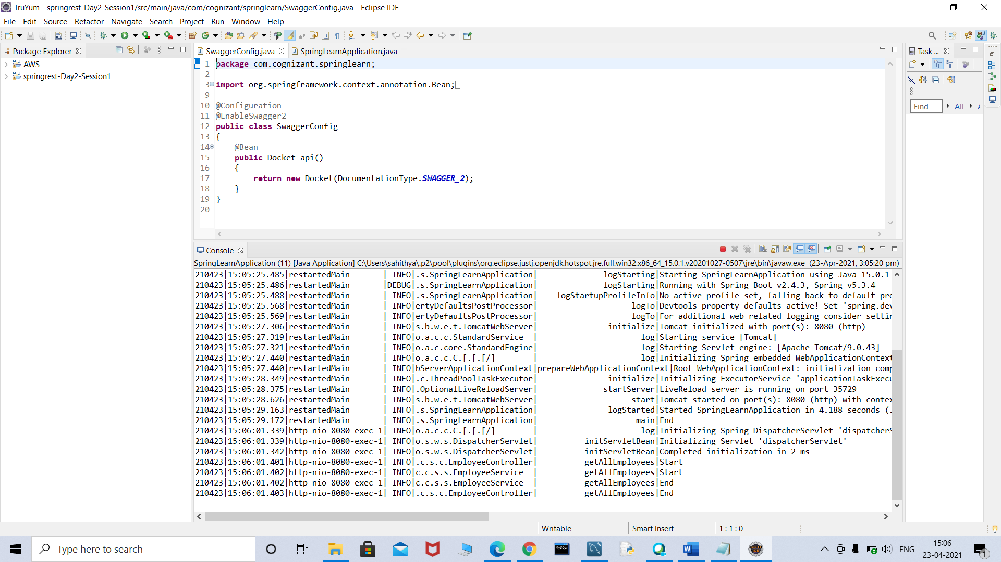

**Start the application locally and type the url in the browser window as shown above**

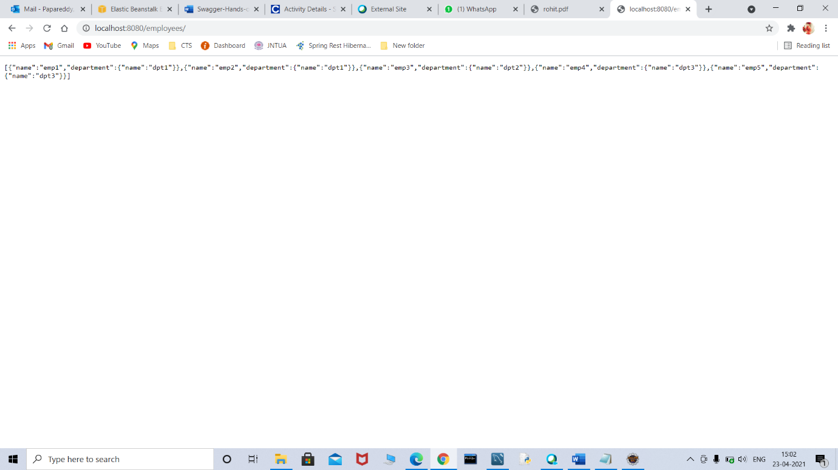

**“localhost:8080/v2/api-docs” and you can see the complete API documentation of your service.**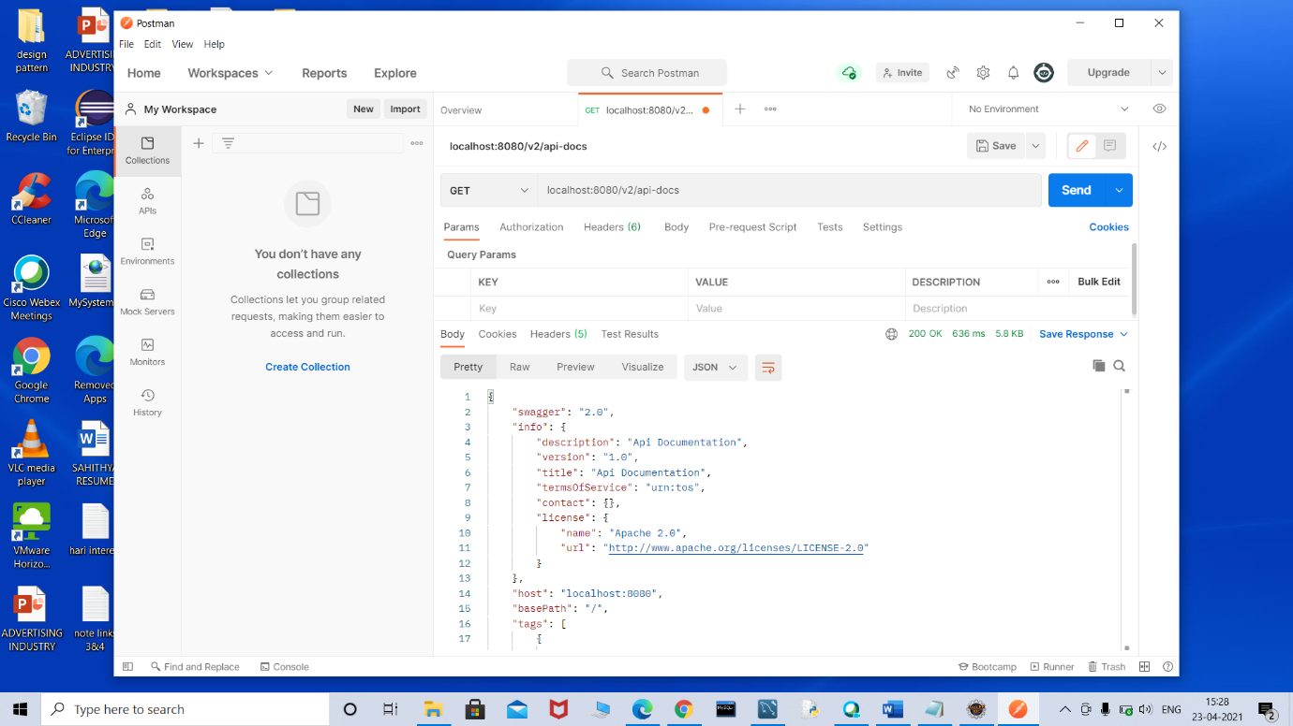

**Spring MVC Client for Spring REST Service:**

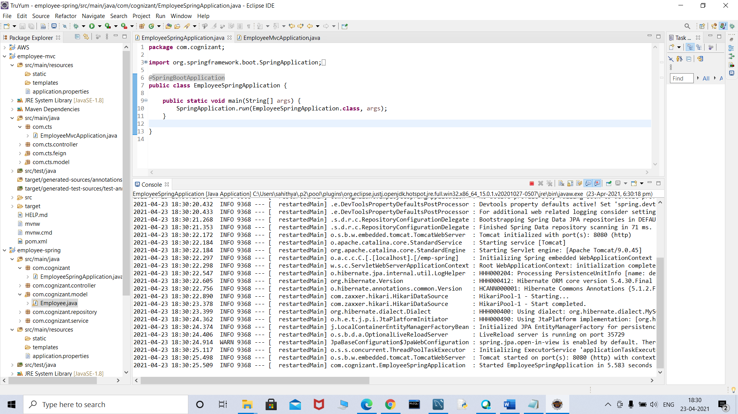

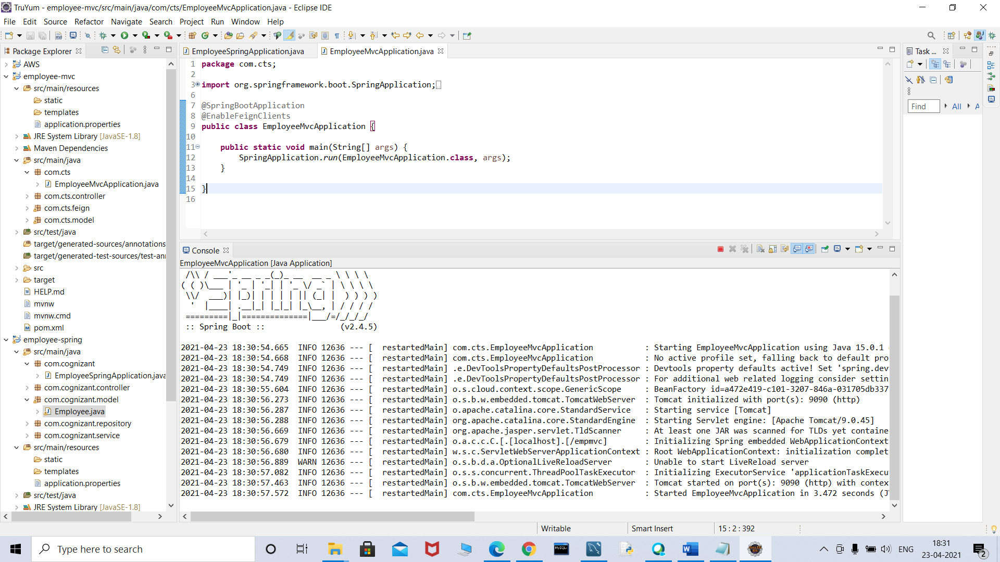

**Output:**

**Details extracted from database**

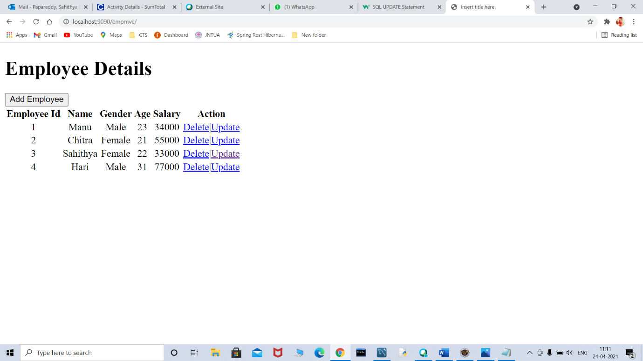

**Adding new employee**

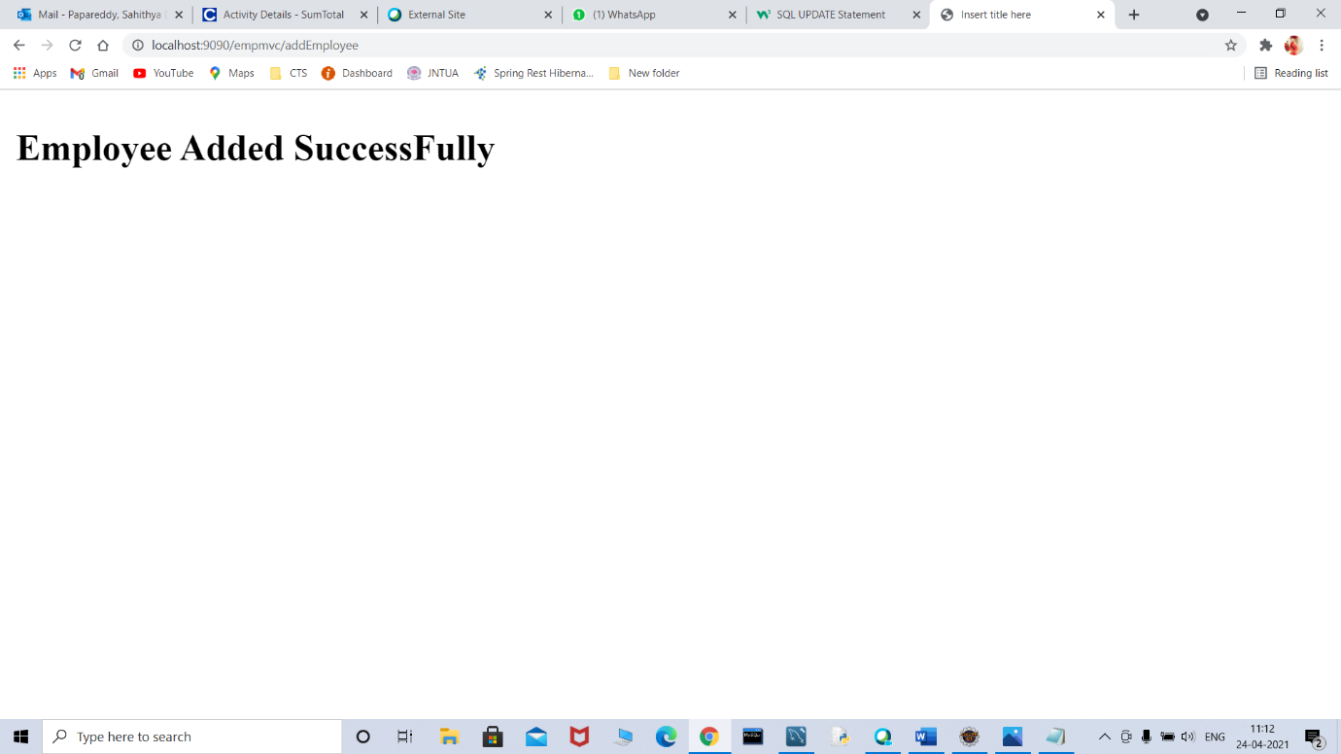

**After adding employee table information**

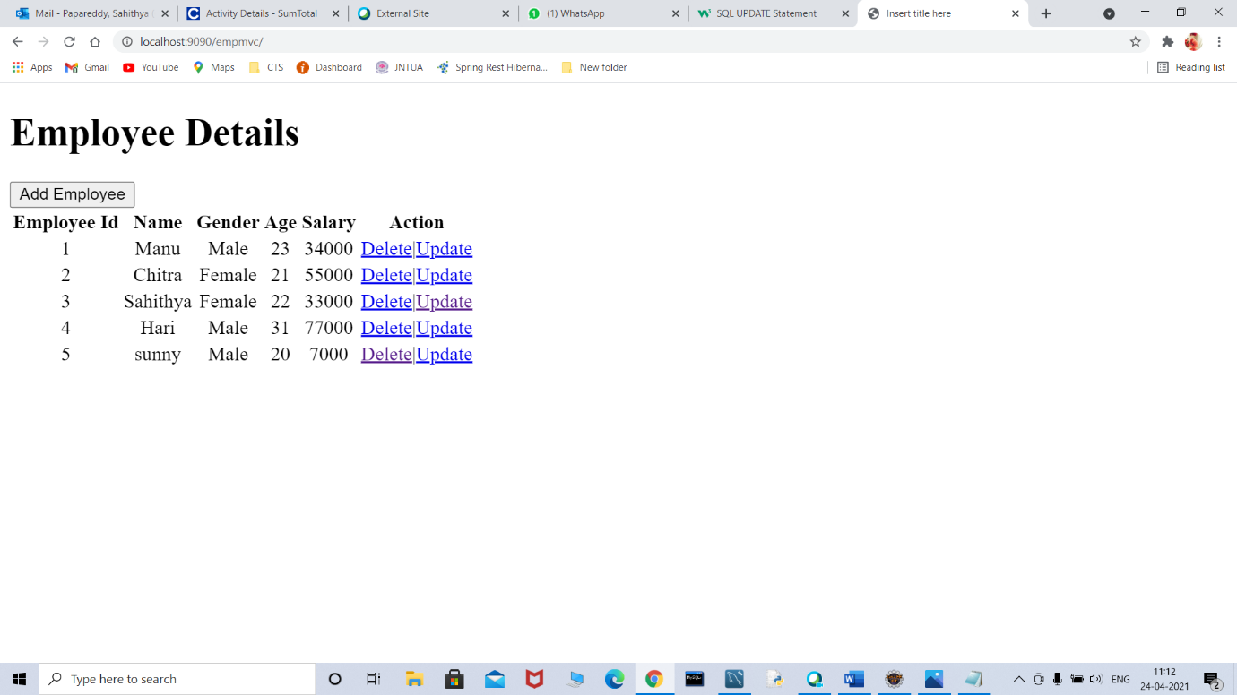

**Updating the employee id 3 as before age is 22 and after updating it is 23**

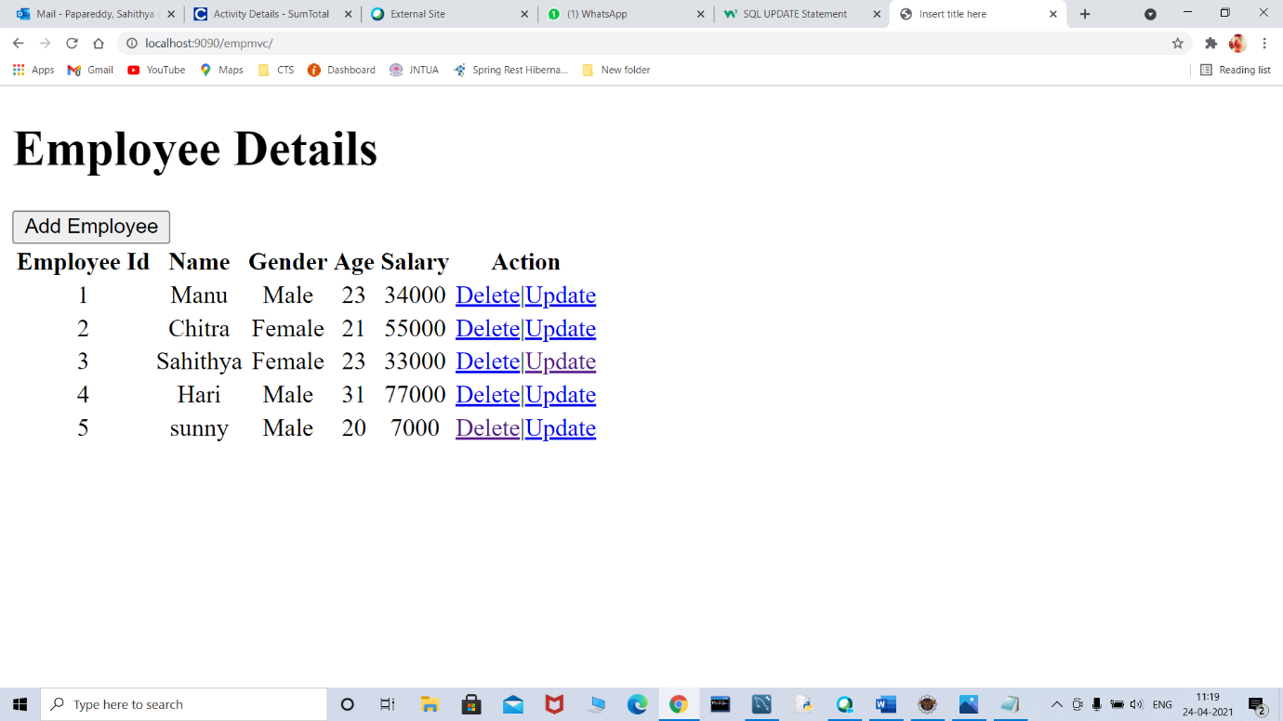

**Successfully employee id with 5 is deleted**

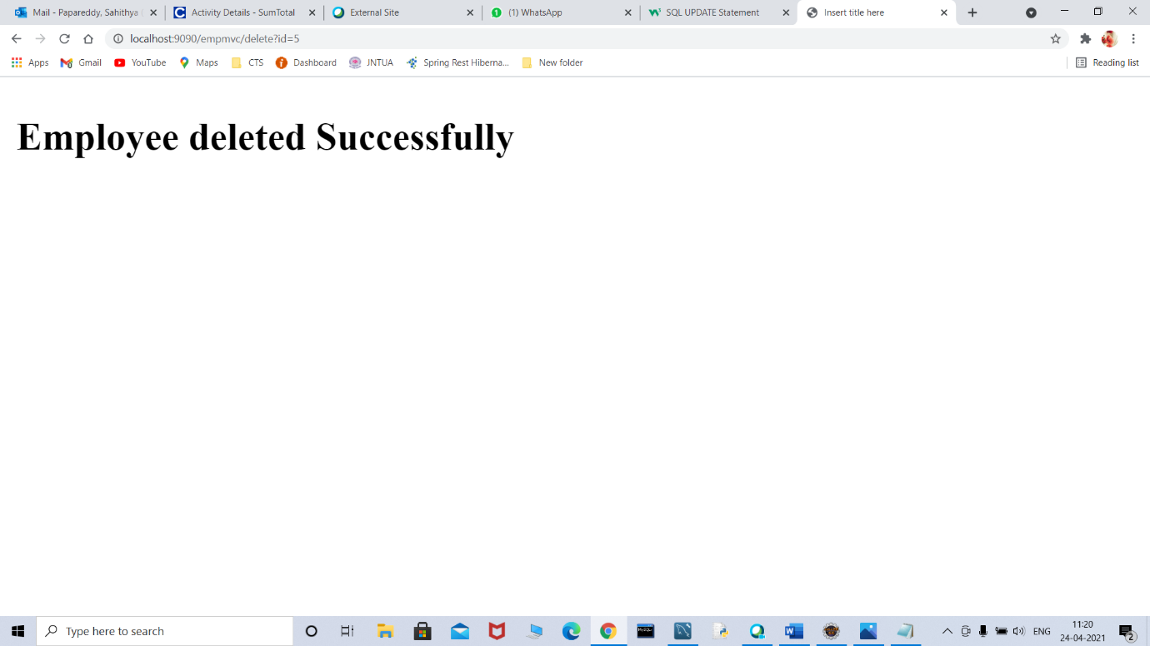

**After deleting table details**

